SIMATS ENGINEERING
ASSESSMENT TOOL
COURSE NAME: Theory of Computation COURSE CODE: CSA13

COURSE OUTCOME COVERED
CO1: Analyze fundamental mathematical concepts of automata theory for formal languages and decision problems(BL:3)
Assessment Tool Weightage: 20%
QUESTIONS: 5 Total Marks:25 Duration : 1 Hour
Simulation
Code of Conduct:
I ARYAN ARUN (192411157) certify that this submission is my original work and that I have adhered to the guidelines specified for this assessment.
I understand that any violation of academic integrity rules will result in disciplinary action. Signature of the student:

SIMATS ENGINEERING
ASSESSMENT TOOL
1 Design a Non-Deterministic Finite Automaton (NFA) for an Automatic Door System based on sensor inputs. An automatic door system can be modeled using an NFA to represent different states and transitions. The system consists of four states: Closed, Opening, Open, and Closing. The input symbols are P (Person detected) and N (No person detected). Initially, the door is in the Closed state. When a person is detected (P), the system may non-deterministically transition from Closed to Opening. Once opened, the system moves to the Open state. If no person is detected (N), the door transitions to Closing and eventually returns to the Closed state. Nondeterminism occurs when the system may remain in the Open state even if a person is detected or may start closing if no detection occurs.
2 Design a finite automaton to model a traffic light control system at a road intersection. The automaton should represent different states corresponding to the traffic lights, such as Red, Green, and Yellow. Define the transitions between these states based on a timer or control signals, ensuring that the sequence follows the standard order (Red → Green → Yellow → Red). Include considerations for timing constraints, such as how long each light remains active, and describe how the automaton handles continuous cycling of signals. Additionally, explain how this model can be extended to handle pedestrian crossing signals or emergency vehicle overrides, ensuring safe and efficient traffic flow.
3 Design DFA using simulator to accept the string the end with ab over set {a,b} W= aaabab
4 Design a Deterministic Finite Automaton (DFA) using a simulator to accept only the input strings “c”, “bc”, and “bcaaa” over the alphabet {a, b, c}. The automaton should begin from an initial state and transition through intermediate states based on the sequence of input symbols, ensuring that each valid string follows a unique path. For example, the string “c” should be accepted directly from the start state, while “bc” should pass through states representing “b” and then “c”. Similarly, “bcaaa” should be processed through a sequence of states that track each additional “a” after “bc”. Any deviation from these exact patterns should lead to a dead state, ensuring that no other strings are accepted. Clearly define the states, transition functions, start state, and accepting states, and implement the DFA in a simulator such as Autosim to verify its correctness.
5 Design a Deterministic Finite Automaton (DFA) using a simulator to accept all strings over the alphabet {a, b} that begin with either “a” or “b”. The automaton should start in an initial state and immediately transition to an accepting state upon reading the first input symbol, since any valid string must start with either “a” or “b”. After the first symbol is processed, the DFA should remain in an accepting state regardless of the subsequent sequence of “a” and “b”, thereby allowing any combination of characters to follow. Additionally, include a dead state to handle invalid or empty inputs if required by the simulator. Clearly define the states, transition rules, start state, and accepting states, and verify the design using a simulator such as Autosim to ensure that all valid strings are accepted and invalid ones are rejected.
SIMATS ENGINEERING
ASSESSMENT TOOL
RUBRICS FOR CALCULATION
Criteria | Weightage | Level 4 – Exemplary (5 Marks) | Level 3 – Proficient (4 Marks) | Level 2 – Developing (2–3 Marks) | Level 1 – Beginning (0–1 Mark)
Conceptual Understanding | 30 | Demonstrates clear and complete understanding of the concept | Good understanding with minor gaps | Basic understanding with some misconceptions | Poor or incorrect understanding
Accuracy of Answer | 25 | Completely correct answer with no errors | Mostly correct with minor errors | Partially correct with noticeable errors | Incorrect or irrelevant answer
Application of Knowledge | 20 | Correctly applies concepts to solve the question/problem | Applies concepts with minor mistakes | Limited or partially correct application | No or incorrect application
Completeness of Response | 15 | Covers all required parts of the question | Covers most parts with minor omissions | Covers only some parts | Incomplete or missing response
Clarity & Presentation | 10 | Clear, concise, and well-organized answer | Understandable with minor issues | Somewhat unclear or poorly structured | Difficult to understand

THEORY OF COMPUTATION
ANSWER SCRIPT
Topic: Simulation of NFA, DFA and finite automaton models

1. NFA for an Automatic Door System
Alphabet: Σ = {P, N}, where P = person detected and N = no person detected.
States: C = Closed, Op = Opening, O = Open, Cl = Closing. Initial state: C. The question describes system behaviour and does not give an acceptance condition, so the Open state O is taken as the accepting state (a modelling assumption).
Formal definition: M = (Q, Σ, δ, q₀, F) with Q = {C, Op, O, Cl}, Σ = {P, N}, q₀ = C and F = {O}.
Transition table:
Current state | Input P | Input N
→ C (Closed) | {C, Op} | {C}
Op (Opening) | {O} | {O}
* O (Open) | {O} | {O, Cl}
Cl (Closing) | {Op} | {C}

Explanation:
• Closed, P: the door may start Opening or may stay Closed (the nondeterministic choice described in the question). Closed, N: it stays Closed.
• Opening: whatever the sensor reads, the opening completes and the door reaches Open.
• Open, P: the door remains Open. Open, N: the door may remain Open or may start Closing (nondeterminism).
• Closing, N: the door returns to Closed. Closing, P: a person appears, so the door reopens (Opening).
Sample run on the input P N N N: C –P→ Op –N→ O –N→ Cl –N→ C. The door opens when a person is detected, begins closing when nobody is detected, and returns to Closed. (On the input P N the NFA ends in O, which is accepting.)
Simulator note: If the simulator (e.g. Autosim) only offers a, b, c, d as labels, use a for P and b for N.
NFA DIAGRAM:

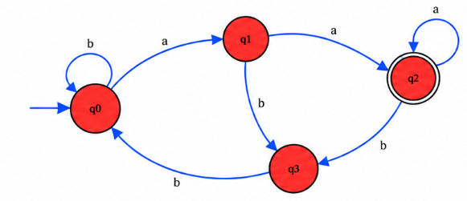

2. Finite Automaton for a Traffic Light Control System
States: R = Red, G = Green, Y = Yellow. Initial state: R. Let T denote the "timer expired" event.
Formal definition: M = (Q, Σ, δ, q₀) with Q = {R, G, Y}, Σ = {T}, q₀ = R. Every state is a valid operating state, so no accepting set is needed.
Current state | Input / event | Next state
→ R (Red) | T: red timer expires | G (Green)
G (Green) | T: green timer expires | Y (Yellow)
Y (Yellow) | T: yellow timer expires | R (Red)

Timing constraints (illustrative): Red = 30 s, Green = 25 s, Yellow = 5 s, so one full cycle takes 60 s. A timer is started on entering each state; when it expires it produces the event T, which fires the transition. These durations are examples; real values depend on the intersection and local rules. A finite automaton itself does not measure time: it only reacts to the timeout events that a timer produces.
Continuous cycling: The transitions form a closed loop R → G → Y → R, so after Yellow the machine returns to Red and the sequence repeats indefinitely, always in the standard order. Green can never follow Yellow directly from Red, and Red never jumps to Yellow, so the order is enforced by the structure of δ.
Extension – pedestrian crossing: Add a pedestrian-request event P and a Walk state W. While vehicles are on Red, the request P moves the machine from R to W; the pedestrian signal stays on for its set duration, and when its timer expires (T) the cycle continues to G. All vehicle directions remain red during W, so pedestrians cross safely.
Extension – emergency override: Add an emergency event E and an Emergency state EM. On E, a Green light first goes to Yellow (a safe clearance), a Yellow light moves to EM, and a Red light moves to EM directly. In EM the emergency route gets green while every conflicting direction is held red. When the override ends (T) the machine returns to R and restarts the normal cycle. Interlocks and minimum clearance times ensure that conflicting directions never show green together.
Simulator note: In Autosim use a for the timer event T on all three transitions.
FA DIAGRAM :
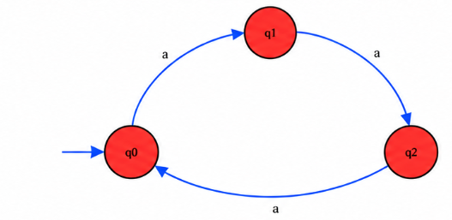

3. DFA that accepts strings ending with “ab”
Alphabet: Σ = {a, b}. Language: L = {w ∈ {a, b}* : w ends with ab}.
States: q₀ = start (no useful progress, last symbol is not a); q₁ = the most recent symbol is a; q₂ = the string currently ends with ab. Initial state: q₀. Final state: {q₂}.
State | Input a | Input b
→ q₀ | q₁ | q₀
q₁ | q₁ | q₂
* q₂ | q₁ | q₀

Test string W = aaabab:
q₀ –a→ q₁ –a→ q₁ –a→ q₁ –b→ q₂ –a→ q₁ –b→ q₂
The computation ends in the final state q₂, so aaabab is ACCEPTED because its last two symbols are ab.
DFA DIAGRAM:

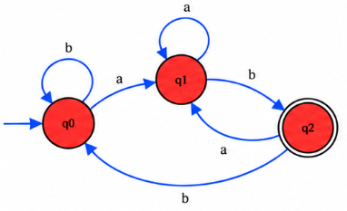

4. DFA that accepts only c, bc and bcaaa
Alphabet: Σ = {a, b, c}. Language: L = {c, bc, bcaaa}. The DFA accepts exactly these three strings and rejects every other string.
States: q₀ = start; q₁ = after b; q₂ = after c; q₃ = after bc; q₄ = after bca; q₅ = after bcaa; q₆ = after bcaaa; X = dead state. Initial state: q₀. Final states: {q₂, q₃, q₆}.
State | Input a | Input b | Input c
→ q₀ | X | q₁ | q₂
q₁ | X | X | q₃
* q₂ | X | X | X
* q₃ | q₄ | X | X
q₄ | q₅ | X | X
q₅ | q₆ | X | X
* q₆ | X | X | X
X | X | X | X

X is a dead (trap) state with self-loops on a, b and c. Any deviation from the three permitted strings, and any extra symbol after a permitted string, moves the machine to X, from which it can never reach a final state.
Verification (test strings):
Input string | Path | Result
c | q₀ → q₂ | Accepted
bc | q₀ → q₁ → q₃ | Accepted
bcaaa | q₀ → q₁ → q₃ → q₄ → q₅ → q₆ | Accepted
b | q₀ → q₁ | Rejected
bca | q₀ → q₁ → q₃ → q₄ | Rejected
bcaa | q₀ → q₁ → q₃ → q₄ → q₅ | Rejected
bcaaaa | … → q₆ → X | Rejected
cc | q₀ → q₂ → X | Rejected
a | q₀ → X | Rejected
ε (empty) | q₀ (not final) | Rejected

DFA DIAGRAM:

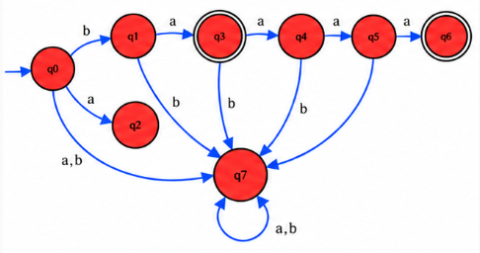

5. DFA that accepts all strings over {a, b} beginning with a or b
Alphabet: Σ = {a, b}. Every non-empty string over {a, b} begins with a or b, so the language is L = {w ∈ {a, b}* : |w| ≥ 1}.
States: q₀ = initial state before any symbol is read; q₁ = accepting state after at least one symbol has been read. Initial state: q₀. Final state: {q₁}.
State | Input a | Input b
→ q₀ | q₁ | q₁
* q₁ | q₁ | q₁

The first symbol (a or b) moves q₀ to q₁, and q₁ stays in q₁ on both a and b, so any continuation is accepted. The empty string is rejected because q₀ is not final. Since every possible input symbol already has a transition, a dead state is not needed here; if a simulator insists on one, a dead state can be added but it is never entered.
Verification (test strings):
Input string | Path | Result
a | q₀ → q₁ | Accepted
b | q₀ → q₁ | Accepted
aab | q₀ → q₁ → q₁ → q₁ | Accepted
bab | q₀ → q₁ → q₁ → q₁ | Accepted
bbbb | q₀ → q₁ → q₁ → q₁ → q₁ | Accepted
ε (empty) | q₀ (not final) | Rejected

DFA DIAGRAM:
